Attack Surface Analysis
Triage Procedure

Revision
Version 1
5/28/25 2:20 PM

SME
Charles Wilson

Abstract
This document describes the procedure used to perform the attack surface analysis triage activity described in the AVCDL secondary document Attack Surface Analysis Report ^{[6]}.

Group / Owner
Security / Security Architect

Motivation
This document is motivated by the need to identify design deficiencies related to cybersecurity as early in the product development process as possible. This is necessary given the nature of safety-critical, cyber-physical systems, subject to certifications such as ISO/SAE 21434 and ISO 26262.
Note: Within the context of this document, the terms security and cybersecurity are used interchangeably. It is presumed that the term security is being used in reference to cybersecurity and not physical security.

Audience
The audience of this document is the cybersecurity practitioner who will be conducting the cybersecurity attack surface analysis triage.

Completeness of Output
Since attack surface analysis is an as-is analysis, it is critical to ensure that the information gathered is as accurate and complete as possible. As with any cybersecurity assessment, it is not the place of the cybersecurity SME to make assumptions on the part of engineering. All information should be sourced from and confirmed by the owner of the element under consideration.
When information is not available for either a given section of the template or parts thereof, this should be noted. Major omissions should be recorded in the cybersecurity risk register.

Disposition of Output
Once completed, the generated output should be managed in the organization’s document management system (DMS) as a document of record.

Entry Criteria
This document assumes that the reader understands the purpose of cybersecurity attack surface analysis. Further, that the reader has read and understood the AVCDL Attack Surface Analysis Report secondary document.

Prerequisites – Development SME

Qualifications
It is required that the development SME is both a qualified and trained development SME with expertise in the element under consideration.
Note: The specific qualifications and training of development SMEs necessary to assert expertise in providing accurate information regarding the element under consideration is outside the scope of this document.
Note: The development group is responsible for determining and making available the appropriate SME for the analysis of the element under consideration.

Knowledge
It is required that the development SME have expertise in the element under consideration.

Prerequisites – ASA SME

Qualifications
It is required that the ASA SME is both a qualified and trained security architect (shown above on title page as Owner) as defined by the NIST NCWF role SP-ARC-002 and detailed in section 12.7 Security Architect of the AVCDL primary document ^{[1]}.

Knowledge
It is required that the ASA SME understands the purpose of cybersecurity attack surface analysis.

Background Information
It is required that the ASA SME has read and understands the AVCDL Attack Surface Analysis Report ^{[6]} and Security Requirements Taxonomy ^{[3]} secondary documents. Additionally, that the cybersecurity SME has taken training relevant to this activity.

Prerequisites – Input Materials
It is required that the threat candidates, created in the ASA analysis activity, be available.
Additionally, it is required that the ASA model for the element under consideration, created in the ASA model creation activity, be available.
It is recommended that the functional and cybersecurity requirements for the element under consideration be available.
Note: The relationship between functional and cybersecurity requirements is covered in Element-level Security Requirements ^{[7]} AVCDL secondary document.

Triage Activity
The workflow diagram for the triage activity of the Attack Surface Analysis Report is shown below.
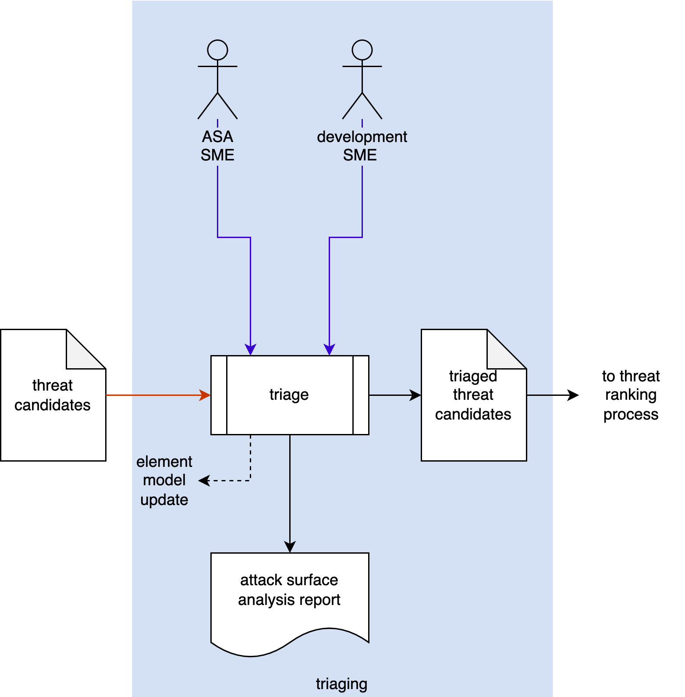
The ASA SME works with the development SME(s) to perform an initial triage of the threat candidates. This triage will yield one of three results:
- A threat candidate is determined to be plausible. It will be marked as such and where possible given a preliminary severity (where the severity designation may be used as a bug bar ^{[8]}).
- A threat candidate exposes incomplete / incorrect information forming the model. The model will need to be updated, and analysis redone.
- A threat candidate is determined to be a non-issue due to circumstances not captured by the model. It will be marked as such and removed from consideration.

Theory
The AVCDL Understanding TARA in an AVCDL Context ^{[5]} elaboration document is intended to illustrate how the AVCDL’s threat modeling activities map into established standards. It does not, however, identify any equivalents to the threat modeling triage activity with respect to other standards. This is shown in the following diagram. The AVCDL considers the triage activity to be a necessary precursor to the threat prioritization process ^{[2]}. The same holds true for the AVCDL’s attack surface analysis triage activity.
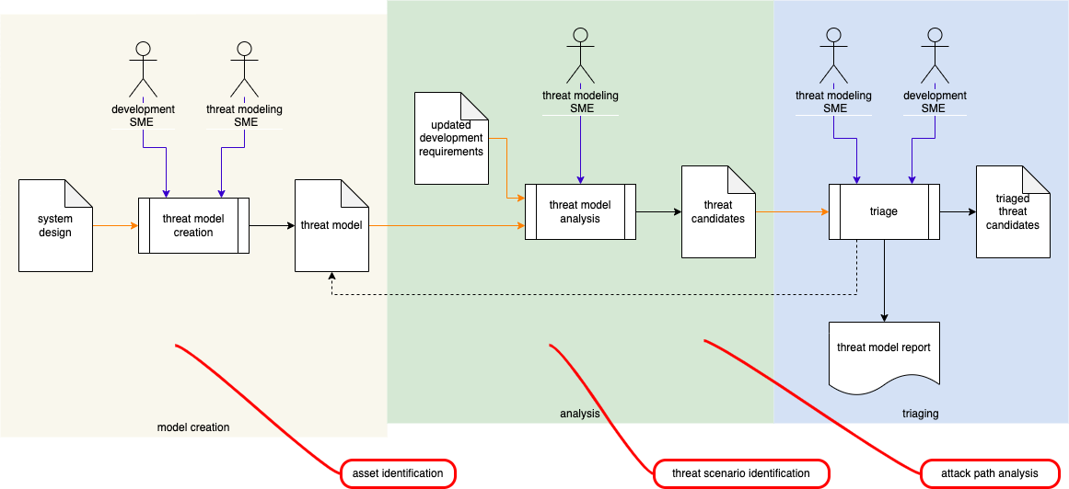

Goal
The goal of triaging the threat candidates resulting from the ASA’s model analysis is to eliminate any candidates which are present due to either inaccuracy of the model or circumstances present within the context of the element which cannot be captured by the model directly.

Methodology

Fundamental Approach
The fundamental approach to threat candidate triage is straightforward. Each of the issues (threat candidates) identified in the ASA analysis activity are reviewed to determine whether they are valid. This determination is recorded and, where necessary, a justification provided.
The determination may be one of the following:
- valid
- insufficient model
- non-issue

Valid
When properly executed the ASA model analysis will result in threat candidates that identify actual deficiencies of the element with respect to proper attack surface behavior.
Note: If the vast majority of the threat candidates are not determined to be valid, there is either an issue with the execution of the analysis or triage process.

Insufficient Model
This determination is appropriate when the development SME indicates that the threat candidate being triaged is invalid, where the cause stems from either incomplete or inaccurate information having been provided during the creation of the model. The model will need to be updated to include new information. Additionally, the analysis will need to be performed again to ensure that the updated model yields the appropriate analysis.

Non-issue
This determination is appropriate when the development SME indicates that the threat candidate being triaged is valid, but because of information not contained within the model. This differs from both incomplete and inaccurate information having been provided during the creation of the model. In this case there is typically a higher level abstraction at play. The model will need to be updated to include a note regarding how this abstraction impacts the element. Additionally, the analysis will need to be performed again to ensure that the updated model yields the appropriate analysis.

Attack Surface Analysis Triage Template
The threat candidate triage activity may be documented using the AVCDL attack surface analysis triage template Microsoft Excel workbook ^{[4]}.
Note: Other forms of documentation are permissible so long as they provide the information laid out in this document.
There are five sheets in the workbook. They are:
- Cover sheet
- Revision history
- Reference documents
- Triage determination
- Legend
These will be addressed in turn.

Duplication of Rows in the Various Sheets
When there is the need to add rows to the various sheets of the workbook, be sure to duplicate an existing row. This is because validation checks are attached to some of the cells which also enables the use of dropdown lists.

Cover Sheet
The cover sheet of the workbook is shown below:
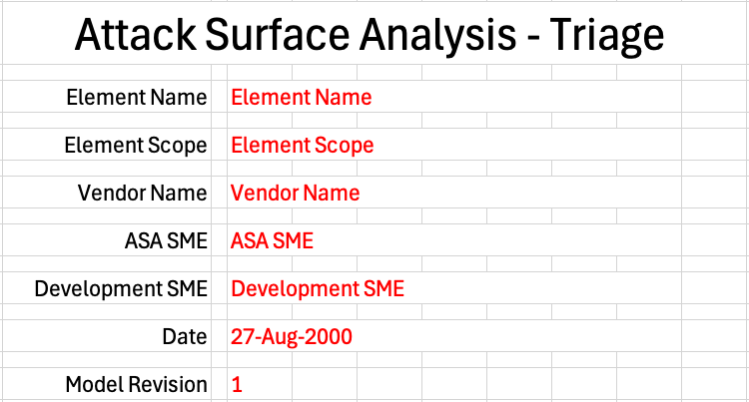
Fields to be completed are shown in red.

Element Name
The element name is the element whose ASA issues are being triaged.

Element Scope
The scope of the element is left to the discretion of the customer. Examples of element scopes include system, sub-system, component, component software (non-OS), and component OS.
Note: In this context, the customer refers to the entity requiring the activity.

Vendor Name
This is the name of the vendor responsible for the element under consideration.

ASA SME
This is the ASA subject matter expert triaging the threat candidates.

Development SME
This is the development subject matter expert providing information about the element.

Date
This is the date when the element’s ASA model analysis triage was created or updated. The date should be updated whenever the document is updated.

Revision
This is the revision number of the document. The revision number is a monotonic and increasing integer, starting at 1. It should be incremented every time the document is updated.

Revision History
The revision history sheet of the workbook is shown below:
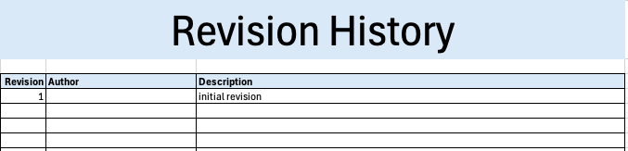

Revision
The revision corresponds to that listed on the cover sheet.

Author
The author corresponds to the ASA SME listed on the cover sheet.

Description
This is a brief description of changes made to the ASA model analysis triage since it was last updated.

Reference Documents
Note: These references are those necessary for the creation of the element’s ASA issue triage.
Note: References to the element’s ASA model, cybersecurity requirements documents, and ASA model analysis should be included.
The references sheet of the workbook is shown below:
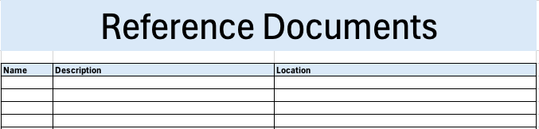

Name
This is the name of the document being referenced.

Description
This is a brief description of the document being referenced.

Location
This is the location of the document being referenced. It may be a physical location or a URL.

Triage Determination
The triage determination sheet of the workbook is shown below:
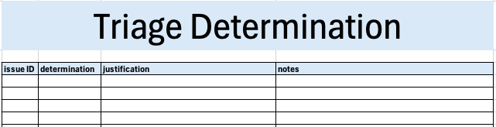

Issue ID
This is the unique element attack surface analysis issue ID.

Determination
This is the determination of the issue’s triage. It may be one of the following:
- valid
- insufficient model
- non-issue
Note: The meanings of these were covered earlier in this document.

Justification
This is the justification for the selected determination.
Note: If the determination is that the issue is valid, no justification is required.

Notes
This is a general notes field.

Legend
The legend sheet of the workbook is shown below:
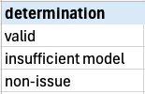
The legend sheet information is used to make the completion of the document easier by providing dropdown lists for common values. It also ensures that spelling errors do not creep into the generated material.
Note: The legend sheet should not be edited. If an unlisted value is required, the template should be separately revised.

Exit Criteria
This procedure is considered complete once the generated output has been entered into the organization’s DMS as a document of record.
Note: The processes and procedures for entering documents into the DMS, or the updating thereof, are outside the scope of this document.

References
- AVCDL (AVCDL primary document)
- Threat Prioritization Plan (AVCDL secondary document)
- Security Requirements Taxonomy (AVCDL secondary document)
- AVCDL attack surface analysis triage template (AVCDL template)
- Understanding TARA in an AVCDL Context (AVCDL elaboration document)
- Attack Surface Analysis Report (AVCDL secondary document)
- Element-level Security Requirements (AVCDL secondary document)
- The Security Development Lifecycle (Howard and Lipner)

